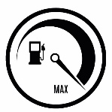 | Fuel  ¼, ½, Full |  |  |  |  |  |  | Mirrors  Condition and cleanliness
 | Lights  Head, tail, brake, reversing, indicators |  |  |  |  |  |  | Body Damage  including glass
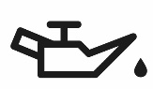 | Oil level |  |  |  |  |  |  | Loose items securely stowed
 | Water levels  Radiator, screenwash |  |  |  |  | 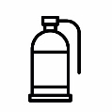 |  | Fire extinguisher  Stowed and in date
 | Electrics  Horn, reversing alarm |  |  |  |  |  |  | Safety Triangle
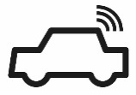 | IVMS  Functioning, driver logged |  |  |  |  |  |  | First aid kit  Stowed and in date
 | Wipers  Condition |  |  |  |  |  |  | Phone  Charged and working
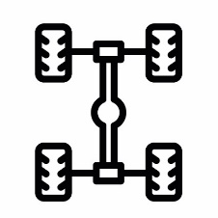  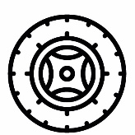 | Tyres  Pressure, tread depth  and condition |  |  |  |  | 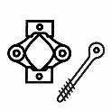 |  | Jack and tools  Stowed
 |  |  |  |  |  | 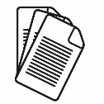 |  | Documentation  Complete for vehicle  and journey
 | Spare/s |  |  |  |  | 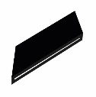 |  | Jacking plate
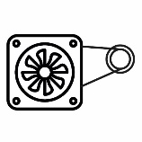 | Fan belts  Condition |  |  |  |  | 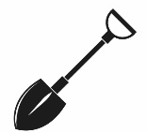 |  | Shovel
 | Brakes  Rolling brake test |  |  |  |  |  |  | Drinking water
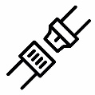 | Seatbelts  Condition
Daily Inspection |  |  |  |  |  | Field Trip Inspection

