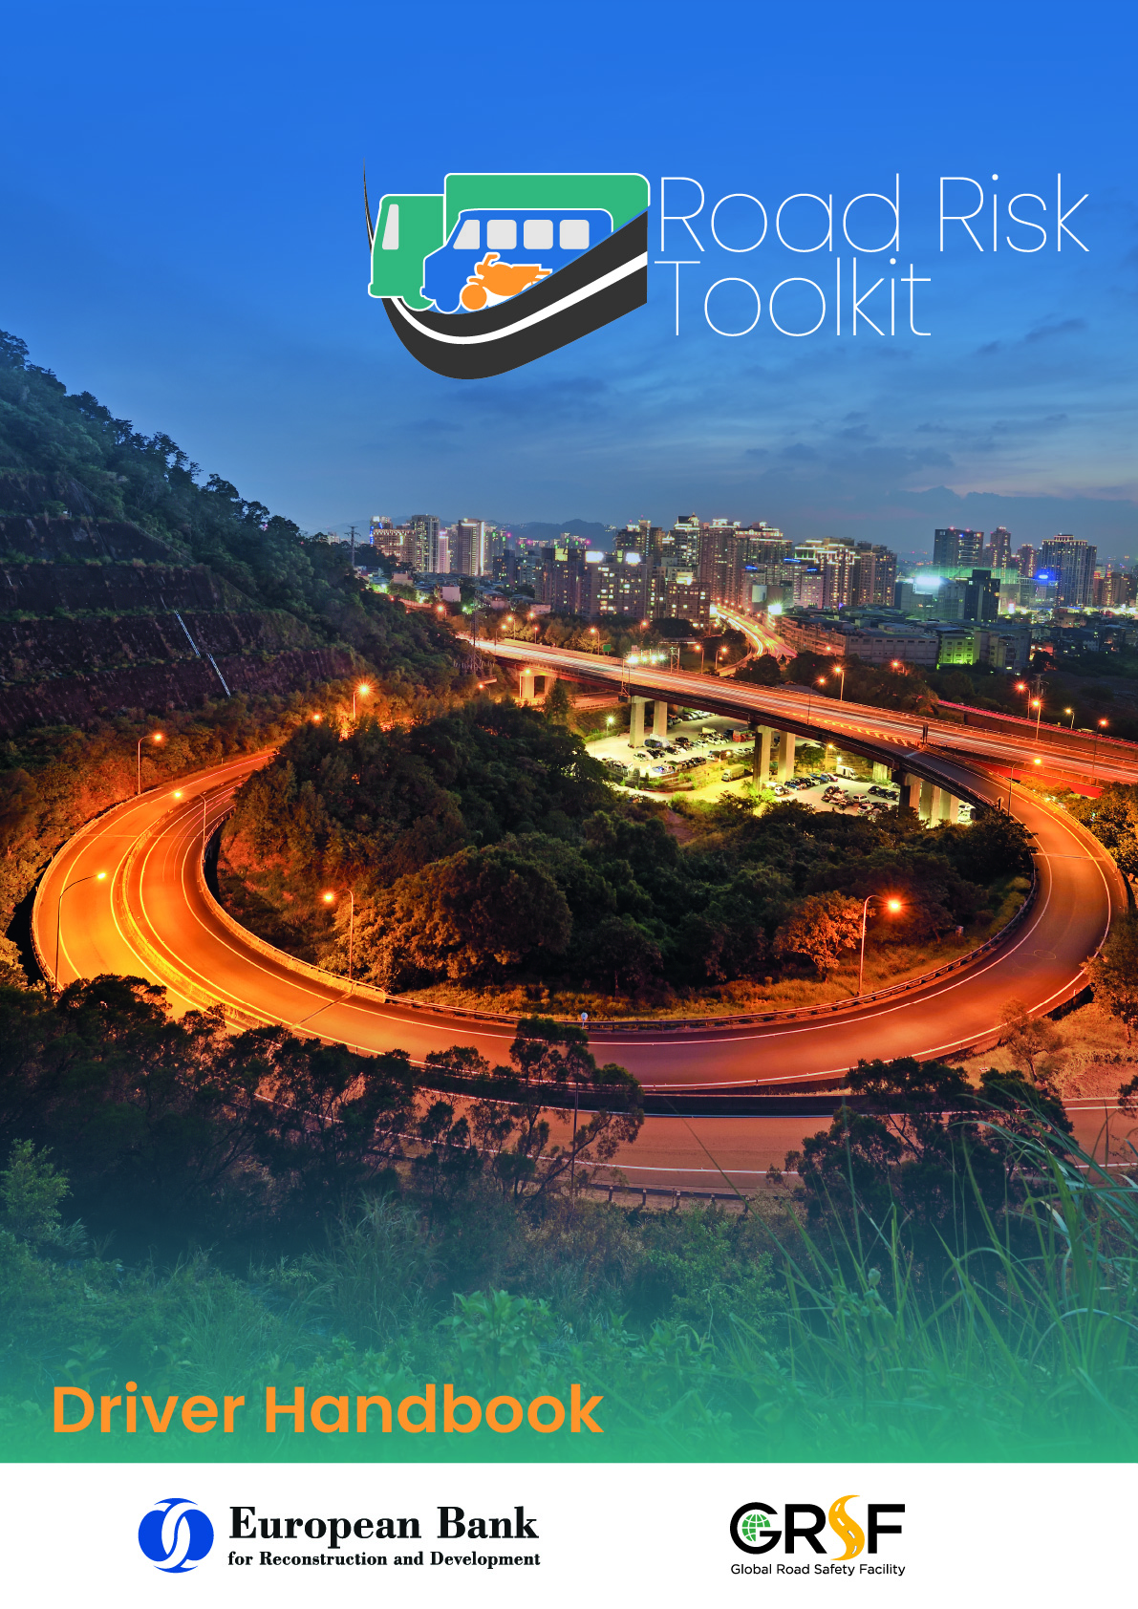

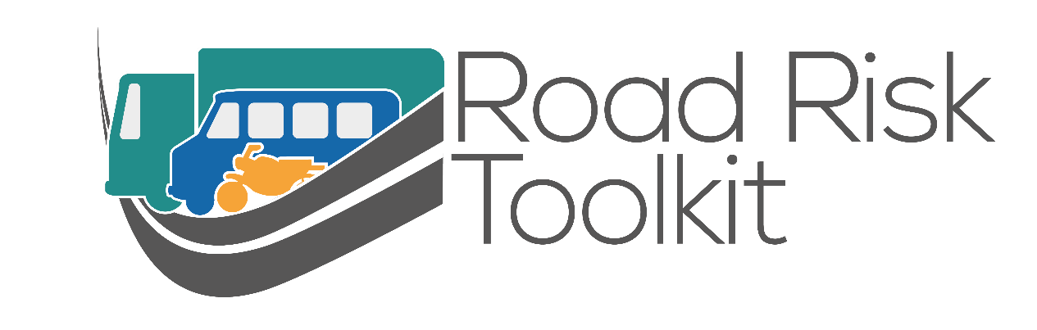

Driver Handbook

Contents
Before you drive 5
Vehicle loading 8
Load securing 9
Driver health 10
Journey planning 14
Seatbelts 16
When you are driving 17
Driver fitness - fatigue 18
Driver behaviour 19
Defensive driving 20
Eco driving 22
Speed choice 23
Other road users (vulnerable road users) 25

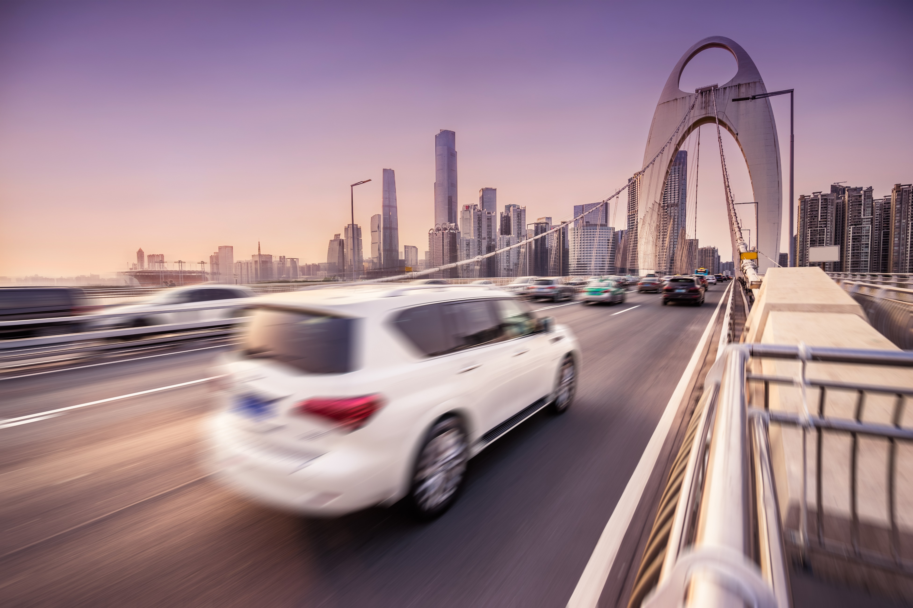

Before you drive
As a driver, you need to be sure that you are legal to drive, and that the vehicle is legal to be driven, before you start to drive.
In most cases, you are the one who will be in trouble with the police and the courts if you or the vehicle are not legal.
As the driver, you are responsible for making sure that the vehicle (and any trailer used) is safe and legal to use at all times.
As well as annual checks and maintenance checks, carry out vehicle condition checks every day before you drive.
- Check tyre condition. This includes damage to side walls, splits and tears and looking for any cracking due to aging.
- Check that tread depth is at least with minimum legal requirements of all countries in which you will travel.
- Check tyre pressures when tyres are cold and adjust to manufacturers recommendations.
- Check all lights and reflectors are clean and working. This includes headlights, rear position lights, brake lights, indicators back and front.
- Check all vehicle fluid levels including oil and coolant, and windscreen washer fluids.
- Check vehicle horn works and is loud enough.
- Check windscreen wipers and washers work effectively.
- Check that the brakes will stop the vehicle will stop efficiently and in a straight line. Check by moving forward at a low speed, and then braking hard. Do this check in a safe place before you start your journey. Do not cause any danger to other road users.

Vehicle maintenance is essential to having a safe and legal vehicle.
Even if there are no legal requirements to put the vehicle through specific maintenance programmes, regular routine maintenance can help to identify issues with your vehicle, before they make your vehicle dangerous to drive.
Maintain your vehicle to at least the manufacturers recommended maintenance schedule.
If you operate your vehicle in challenging conditions (mountainous areas, dusty environments, gravel roads, extremes of temperature) then you may need to maintain your vehicle more often than the manufacturers recommendations.
- Does the vehicle comply with all legal requirements? Registration? Official vehicle condition checks?
- Do you have the right paperwork to prove that you and the vehicle meet these legal requirements?
- Do you have the right paperwork for all the countries/states you will travel in?
- Make sure that any certificates required do not expire before the end of the journey.
- Make sure you have all vehicle and trailer documents with you and store safely.
Are you operating in a country or state that requires vehicles to be insured? If “yes”, are you insured to drive the vehicle you will be using?
- Does that insurance cover you to carry those passengers or those goods for work?
- Are all of the details kept up to date with the insurer?
- Does the insurance cover all the countries where you will be driving?
If you are using your own vehicle for work, make sure your vehicle insurance is valid for the use on work journeys.
- Is your driving licence valid and in date for the entire journey?
- Does your licence allow you to drive all the vehicles you are going to use?
- Do you have the right authorisation for your specific load e.g. Hazardous goods?
- Is your licence valid in all countries that it will be used in?
- If any additional driver will be used during the journey, ensure their licence is also valid
- Carry your licence with you if required to do so.

Vehicle loading
As a driver, you need to make sure that your vehicle is safely loaded, before you start to drive.
Even if someone else loads the vehicle for you, it is your responsibility to make sure the load is secured correctly. If the vehicle is not loaded correctly, it will affect the handling of the vehicle and make it more difficult to control. The load may even come loose and cause a crash.
You will usually be the one in trouble with the police and courts if the load is not secure, so it makes sense to do the checks yourself.

Load securing
Loads which move are dangerous.
A load which moves while you are travelling can cause you to lose control of the vehicle.
A load which moves when you have a crash can kill or injure you.
- Can the load be put in a special area away from the driver and passengers?
For example, in the trunk of a car, in the load bed of a pick-up, behind a luggage screen in an SUV etc.
- Wherever the load is, is it properly secured to stop it moving as you drive?
Heavy loads need securing even more than light ones – their weight will not stop them from moving.
If the load is in a van, SUV or pickup, the load should be secured by tying it down.
There are many ways to do this, including ropes, ratchet straps and chains.
- Is the load secured well enough that in a crash it will not enter the area occupied by the driver and passengers, potentially injuring them?
- Is your vehicle appropriate for the load you will be carrying?
- Would a bigger vehicle or a different type of vehicle be safer?
For example a pickup truck instead of a car, or a tanker truck instead of barrels in a pickup.
The load should be distributed as evenly as possible. This will spread the weight more evenly across the axles of the vehicle and affect the handling of the vehicle as little as possible.
Keep the heaviest parts of the load as low as possible to avoid raising the centre of gravity of the vehicle.
Vehicles with a high centre of gravity are more likely to lose control or roll over.

Driver health
As a driver, you need to be aware of your general health and how it affects your ability to safely drive for business purposes.
- Good eyesight is essential for safe driving.
- If a driver cannot see well ahead, they cannot spot potential hazards on the road.
- Regularly check that you can read a vehicle number plate in daylight from at least 20m, and make sure that you can see clearly to drive in darkness too.
- Have your eyesight tested regularly to identify any problems.
- If you have to wear spectacles or contact lenses to drive, do not drive without them.
Alcohol affects your ability to concentrate, causing fatigue or drowsiness.
Alcohol also affects your ability to make rational and informed decisions whilst driving.
- Never drive whilst impaired by alcohol.
- Never drive whilst over the legal drink drive limit.
- Be aware that there are different limits for different countries.
- Be in possession of the relevant self-testing alcohol devices if required by any country you are driving in.
- Do not rely on the legal accuracy of self-test devices as this can vary from manufacturer to manufacturer.
- Be aware of “morning after” alcohol levels. You may feel fine to drive but may still be impaired (and over the legal limit) from drinking alcohol the “night before”.
Everyone’s body processes alcohol at a different rates.
Even alcohol at limits below a legal minimum may impair your driving.
If there is any doubt do not drive.
Never drive when you are impaired by drugs.
Illegal or legal “recreational” drugs may be culturally acceptable in some countries, but they will impair your ability to drive safely. This may include plants like coca leaf or khat.
Substances like these can affect your decision making, your vison, your concentration, your reactions and your appetite for risk.
The chemical strength and make up of such substances can be unknown.
As there is no consistent control over what they contain they may be extremely harmful and have a different effect to when you took the same thing before.
The effects of these substances can change from one person to another.
Some medication given to you by a doctor or bought from a shop can affect your ability to concentrate or may cause fatigue or drowsiness.
Do not take a chance that you will be able to drive safely, if there is any doubt do not drive.
Consult with health professional and/or line manager if you are taking any medication that may affect your ability to drive safely.
If you are not feeling well your ability to concentrate and drive safely is likely to be seriously impaired. This can be something as simple as having caught a cold.
If you have any doubts about your ability to drive safely take medical advice.
Always discuss with your employer any relevant medical condition, temporary or long term, that may affect your ability to drive safely.

Journey planning
Many problems on journeys can be avoided by safely planning the journey before you leave.
Many journeys need active Journey Management.
This means making a formal plan for when you will leave, when and where you will take rest breaks, and what time you should arrive.
This should be monitored by someone else who is not travelling with you so that you can check in with them by phone or radio so they know the journey is proceeding according to the plan.
Even if your company doesn’t have a formal system for monitoring your journeys, you could get a colleague, family member or friend to take on this role for you.
If you don’t arrive where you should do at the right time, they can activate a plan to assist you, whether the problem is a breakdown, a security incident, or one of the many other things which can delay you on the road.
Driving in congested traffic conditions can be very tiring.
It is also time consuming and consumes a lot of fuel per km driven – bad for costs and for the environment.
Planning your journey to be before the congestion or after it (rather than being stuck in the middle of it) is a good way to make sure you arrive rested, at a predictable time, and having used less fuel to reach your destination.
Sometimes a longer route which avoids congestion can actually take less time and use less fuel.
Some routes may have worse weather conditions than others.
For example, high routes may have more snow, routes with exposed roads may be worse in high winds, low lying routes may be more subject to flooding, some routes may have more fog than others.
Considering these issues when planning your journey can help you to plan the best route.
You may even need to postpone your journey, bring your journey forward, choose a different route to usual or even cancel the journey completely if the weather conditions are too bad to carry on as normal.
The safest route is not always the shortest one.
Some types of road are safer than others – for example a road with a central crash barrier dividing the traffic travelling in opposite directions is safer than one without.
- Some routes have a history of many bad crashes.
- Some routes have junctions which are difficult to use.
- Some routes may have badly maintained roads.
- Some routes may be subject to security issues.
Taking time to choose the safest route is always the wise choice.
Taking a route which is safer, even if it is longer or may take more time, may prevent you being involved in an incident, or being delayed by incidents involving others.
Is your journey actually necessary?
Can the objective be achieved by other means? This may mean a meeting taking place by video conference or combining loads so that goods are added to a journey being made by another vehicle to the same destination.
Is driving the safest way to make the trip? Is rail an option, for example, or for longer journeys, flying?
Can you combine this journey with another one, for example visiting the same town once a month for four customers instead of having to make four trips to the same town?

Seatbelts
Seatbelts are one of the most basic safety features on your vehicle. Using it can save your life.
Wearing a three-point seat belt which passes across your lap and then up over your shoulder is safest.
If there is a three-point seatbelt, always wear it across the waist and up over the shoulder.
If there is only a lap belt, wear this securely fastened across your waist.
Seat belts also reduce the risk of death for a front seat passenger by 45% and cut the risk of serious injury by 50%.
Rear seat passengers are three times more likely to die if they are not wearing a seatbelt.
Passengers who are not wearing their seatbelt will also be thrown around the car in a crash, injuring you as well as themselves!
Don’t allow any passenger to travel without a seatbelt where one is fitted – refuse to drive until they are wearing it.
It is important not to carry more passengers than there are seat belts in the vehicle.
If you don’t wear a seat belt, you are 30 times more likely to be thrown out of the vehicle.
80% of people who are thrown out of the vehicle are killed.
To keep yourself safe, always wear your seatbelt when driving – no matter how short or slow the journey.

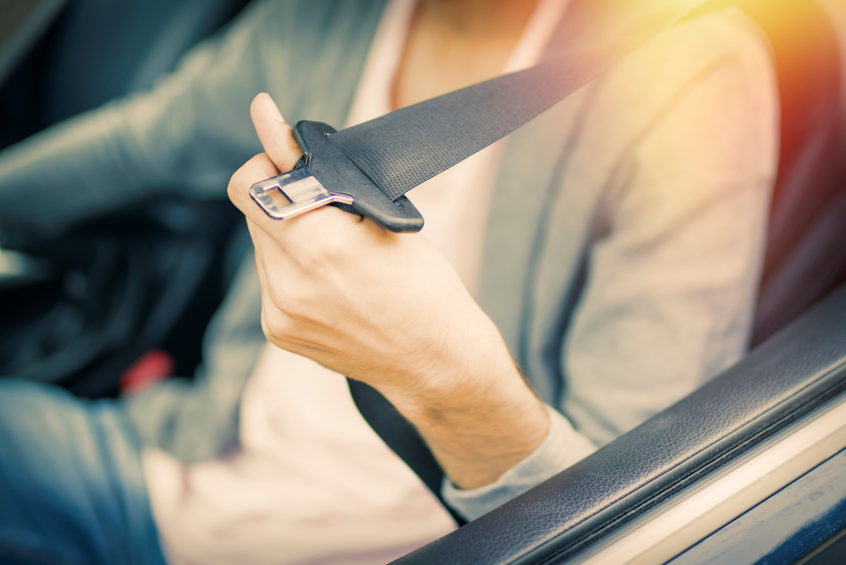

When you are driving

Driver fitness - fatigue
Driving whilst fatigued is a potential killer. Research shows that up to 20% of crashes on some roads are fatigue related.
Fatigued driving is not always longer journeys or longer working days.
Fatigue can affect anyone who drives when they are tired and can lead to a driver falling asleep at the wheel.
- Where possible, avoid making long journeys between midnight and 6am, when natural alertness is at a minimum.
- Plan your journey to take enough breaks. A minimum break of at least 15 minutes after every two hours of driving is recommended.
- Do not start any journey if you feel tired.
- Do not ignore the feeling of fatigue. It can lead to a crash which may kill you and others.
- You cannot carry on driving safely whilst fatigued.
If you feel sleepy, stop in a safe place away from other moving vehicles. Do not stop on the side of a busy road.
If you can stop and sleep for several hours, do.
If you cannot stop for long, a 15-minute nap will help you to continue for a little longer but is not a cure!
If available, drink a caffeine drink (for example, two cups of coffee) before you have your nap. The caffeine will get into your body as you are waking from your nap.
Your driving will become unsafe a long time before you start to fall asleep.
- You will find it difficult to concentrate.
- You don’t spot things.
- You take longer to react, so stopping distances are longer.
- Your vehicle could sway on the road or drive off the road.
- You could drive into the back of a vehicle in a queue.
The following can all be causes of fatigue:
- Not enough sleep
- Poor quality sleep
- Shift workers driving at a time when you are used to sleep
- Driving too long without breaks
- Medical conditions
- Drinking alcohol increases sleepiness
- Stress
If you feel tired, or it’s time for one of your rest breaks, always stop in a safe place well away from any traffic to take a rest. Other road users may also be tired or inattentive and crash into you!
Natural alertness is at its lowest from midnight to 6:00am
Only sleep can cure tiredness
Taking a break for fifteen minutes after every two hours of driving helps reduce fatigue

Driver behaviour
Concentration is a key part of being able to spot hazards, and to make informed choices whilst driving.
Your level of concentration affects your ability to react to hazards and changing conditions.
Many factors can affect your concentration level including fatigue, alcohol, drugs, stress, trying to multitask, or mobile phone use.
Minimise in car distractions at all times.
Do not use a mobile phone while driving, even if it is legal where you are.
Even “hands free” mobile phone use has a significant negative affect on your ability to concentrate and increases your risk of crashing.
Your “reaction time” is the time it takes you to see a hazard and decide what action to take.
A fully concentrating driver usually has a reaction time of between 1-2 seconds.
A driver in a state of “autopilot” can have a reaction time of up to 9 seconds.

Defensive driving
Defensive driving means driving in such a way that you give yourself the best chance to avoid mistakes - yours and other people’s!
The larger and heavier your vehicle is, the further it will take to stop.
Develop a planned way to identify and deal with any hazards and it will become the way you always drive.
- Do not change the way you drive because of pressure from other road users.
- Practice improving your concentration.
- Improve your awareness of hazards.
- Always expect that other road users will cause you problems by their actions.
- Try to get more driver training – however good you are there is always more to learn.
Always drive so that you can stop well within the distance you can see is clear.
Braking distances can increase significantly on different road surfaces. It will take a lot longer to stop on a wet road, or on a dirt road.
Make sure you are aware of how well your vehicle can brake.
Consider the road surface you are driving on.
Weather conditions can also have a significant effect on braking and stopping distances.
In poor weather always try to avoid hard braking, harsh accelerating or harsh steering.
Spot hazards as early as possible. Look for clues there is a hazard, such as road signs, road condition, road markings, other road users behaviour or evidence of their past behaviour such as skid marks on the road surface.
Decide what may happen and then put yourself in the best position on the road to see the hazard early and to deal with it.
For example, when approaching a right-hand bend be as far over to the left of the lane or road as you safely can allowing for all other road users. This will help you to see round the bend and see hazards earlier.
If there is a junction ahead on your left-hand side move as far to the right of your lane or your side of the road as you safely can.
Give yourself as much space between your vehicle and any hazard as you can.
When we drive our appetite for risk and behaviour can be very different to our behaviour in other circumstances.
Always make informed choices and decisions when driving.
A major error and cause of road crashes is drivers failing to look properly – take longer looking at junctions.
You cannot prevent mistakes made by other road users.
Assume that other road users will make mistakes.
Always drive in such a way that you give yourself the best chance to avoid mistakes, yours and other people’s!

Eco driving
Eco driving is the title used to describe driving in a way which uses as little fuel as possible.
This is better for the environment, is a smoother, safer driving style, and also saves money.
- Check tyre pressures: under-inflated tyres cause more fuel to be used and affect vehicle braking and handling stability
- Make sure the vehicle is properly maintained, running efficiently and brakes are not binding/dragging.
- Reduce unnecessary extra loads or weight carried on or in the vehicle.
- Avoid short journeys.
- Switch the engine off if you are stationary for more than a few seconds.
- Slow down! More speed means more fuel used.
- Avoid harsh braking and harsh acceleration.
- Anticipate and plan ahead, recognise hazards to minimise the need for braking and accelerating.
Eco driving can:
- Reduce the fuel you use by up to 15%
- Reduce the wear and tear on vehicles and so reduce maintenance costs
- Reduce repair costs from road crashes or damage from poor vehicle handling
- Improve company reputation by visible improvement in driver behaviour and company green credentials.
- Improve staff wellbeing and reduced work stress and absence
- Benefits drivers and passengers as well as the company.
- Is a more relaxed and comfortable, stress free driving experience.
- Improves safety on the journey.
- Is a skill that can be used outside of work and shared with family and friends.
- Reduces pollution, damage to environment and improves health.
- Reduces money spent on fuel.

Speed choice
Driving too fast increases the risk of being involved in a crash and makes the crash more likely to be a serious one.
Driving within the speed limit for the road is not enough – you must also drive at a speed which is right for the conditions.
Always make informed decisions about your own ability to slow your vehicle or stop if required and choose a speed to match.
If you have been driving at higher speed for a long time, be aware it may take you longer to stop than you expect.
Have a realistic idea of your own abilities and behaviours as a driver – not a false belief that you are better than you really are.
Concentration and observation are key. Always drive at a speed that will allow you to stop well within the distance you can see to be clear.
Be aware of the braking and handling characteristics of the vehicle you are driving – a loaded vehicle takes longer to stop.
The condition of the tyres including the tread depth, the age of the tyre, the type of the tyre (such as re-treads), and tyre pressure will all affect your braking distance, which in turn should affect your speed choice.
The type of road surfaces and its condition can also significantly increase stopping distances.
In wet conditions, extreme heat, snow, ice etc stopping distances can be significantly affected.
Stopping distance are also significantly increased by a lack of concentration or awareness of hazards.
Drivers speed for a variety of reasons: some are temporary such as feeling a need to complete a journey more quickly, some are due to the driver’s attitude, behaviour and appetite for risk.
Research has shown that actual reduction in journey times are not as big as drivers expect – but the increase in risk is very real.
You should drive at a speed that lets you properly assess actions of other road users or other road hazards, and to stop in time to avoid a crash.
Many drivers do not realise that they are exceeding the posted speed limit either because they have failed to pay attention to their surroundings and their speedometer.
- Driving too fast increases the risk of being involved in a crash and makes the crash more likely to be a serious one.
- Driving too fast not only affects road safety but also has a negative effect on the environment by increasing exhaust emissions, air pollution, traffic noise, and quality of life for people living or working near roads.
- Driving too fast also increases fuel consumption and cost.
- Driving too fast not only affects road safety but also has a negative effect on the environment by increasing exhaust emissions, air pollution, traffic noise, and quality of life for people living or working near roads.
Many drivers do not realise that they are exceeding the posted speed limit either because they have failed to pay attention to their surroundings and their speedometer.

Other road users (vulnerable road users)
Some road users are at a significantly higher risk of being killed or seriously injured when involved in a collision with a motorised vehicle.
Vulnerable road users are those not protected by being surrounded by a vehicle.
Vulnerable road user is a widely used term to include;
- cyclists
- motorcyclists
- pedestrians
- children
- the elderly
Vulnerable road users are particularly at risk due to their lack of physical protection compared to motor vehicle occupants.
- Always indicate any lane changes or turning manoeuvres when there are other road users nearby
- Check carefully in mirrors for any VRU before changing course, direction or speed.
- Give cyclists and other VRU’s as much space as you can as they can be unpredictable, may be unsteady or need more space or time than you anticipate.
- When overtaking a VRU be aware that they may suddenly move into your path in order to avoid a pothole or defect in the road surface that you may not be aware of or consider a hazard to your own vehicle.
- Keep out of any areas on the road that are designated for VRUs only like pedestrian or cycle lanes.
Many crashes occur between Large Goods Vehicles and cyclists when the LGV is turning
Similar problems can affect large buses and coaches
Be particularly aware of all the blind spots on the vehicle you are driving and check frequently when on the move particularly areas beneath the doors and the front of the cab
Always consider fitting additional warning signs on the vehicle to let VRU’s be aware of the difficulty the driver may have in seeing them.
On an LGV consider fitting additional under run protection measures, make sure this is in good working order.
Consider attending additional VRU awareness training courses for drivers of large vehicles.
It is not possible for vulnerable road users to be segregated (such as footways, cycle lanes, motorcycle lanes) in most road conditions so you need to take all steps you can to protect the VRU
Make sure that you are sitting in the vehicle in a position where you can see as clearly as possible.
Adjust all internal and external mirrors to give the best possible view of other road users.
Take extra care at junctions and make sure you look properly before you move – including looking all around and over your shoulder rather than just relying on your mirrors.
Observation and anticipation of the VRU are vital in order to reduce the risk of a crash and the seriousness of injury if a crash occurs.
Cyclists, motorcyclists and pedestrians are involved in 50 % of fatal crashes.
Vulnerable road users are particularly at risk due to their lack of physical protection compared to motor vehicle occupants.
Some vulnerable road users such as children and animals can be unpredictable.
Some may not be able to see or hear vehicles as easily as a driver anticipates or require more space or time to avoid them.

